**Selenium April 2014**

**Day1**

* First 3 chapters : Selenium IDE
* Core Java tutorials
* Selenium webdriver
* **What is Test NG?**

TEST NG is similar to JUNIT slightly different from JUNIT

* **What is the difference between Selenium RC, Webdriver, Test NG and JUIT**

Selenium RC server /web driver/ Test NG / JUNIT are 4 different things. It doesn’t matter if you learn TEST NG and RC or TEST NG and web driver.

Please use the step by step installation mentioned in the Selenium Installation Document provided with Welcome pack. For latest versions compatibility, please find the below versions and installation path:

Mozilla Firefox – Version 19 ([http://www.mozilla.org/en-US/f…..refox/new/](http://www.mozilla.org/en-US/firefox/new/))  
Selenium IDE – Selenium IDE 1.10.0 (<http://docs.seleniumhq.org/download/>)  
Firebug – Firebug 1.11.2 (<http://getfirebug.com/>)

**Go to Seleniumhq.org – click Selenium download you would get the entire Java packages**

Selenium Server Standalone – selenium-server-standalone-2.31.0.jar (<http://docs.seleniumhq.org/download/>)  
Selenium Java – selenium-java-2.24.1.jar  
Junit – junit-4.8.1.jar  
POI – poi-3.7-20101029.jar

**Things to download for Eclipse to Use Webdriver and JUNIT**

1. **Seleniumhq.org :** get the latest Selenium IDE for the Firefox browser
2. **Eclipse**
3. **Java Eclipse :** selenium-java-2.24.1.jar: For Eclipse to understand what is a firefox driver, or a webdriver, we need to download the “JAVA” under language from <http://docs.seleniumhq.org/download/>
4. **JUNIT Jar file:** <http://sourceforge.net/projects/junit/> download Junit – junit-4.8.1.jar

**Day2**

**Eclipse:**

1. Create either a new workspace or in the same workspace create a new Java project
2. Create a new class
3. Copy the Selenium IDE to Java/Junit4/Webdriver

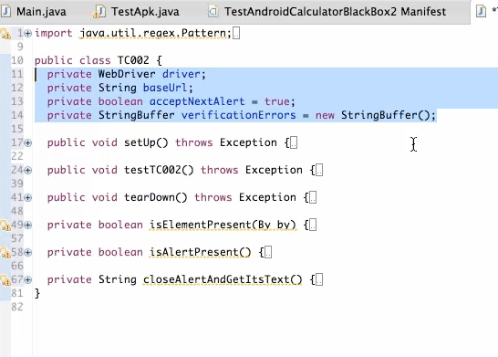

**Lines 11 to 14**

* Lines 11 to 14 are variables or objects that are created to use in the code – Stores values has a name and a type.
* For example driver or base url above is a Name of the variable that is used to identify to call anytime in the code to call.
* String is a type
* Value is a value we assign going forward to base url etc

**Import**:

Imports from the Ocean Java library. Import what I want for that purpose instead of importing the entire library.

**Annotations**:

There are few different annotations for Junit and for Test NG. But the purpose is similar

Following are the annotations for jUnit

@Before:

@Test

@After

Java code can recognise looking at my code. So when we execute the code, Junit tries to execute everything within the annotation @Test and run whatever within that function or a test case within.

Private Webdriver driver;

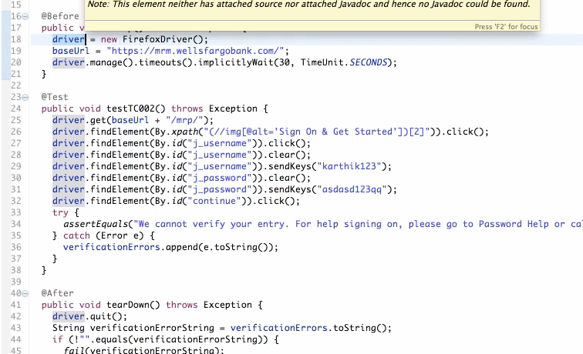

* driver = new FirefoxDriver (I have assigned the driver to firefox driver to interact with web browser)

Driver is a variable of type webdriver

Webdriver is an object of class webdriver

where the webdriver is pointing to firefox browser.